Phone Screen Clicker

- Installing/Setting Up Arduino extension into Visual Studio Code.

Goto https://marketplace.visualstudio.com/items?itemName=vsciot-vscode.vscode-arduino

Click install. It should open visual studio code and then you can install it from there.
The next thing I would do is set up a shortcut for sending serial commands.

Hit F1
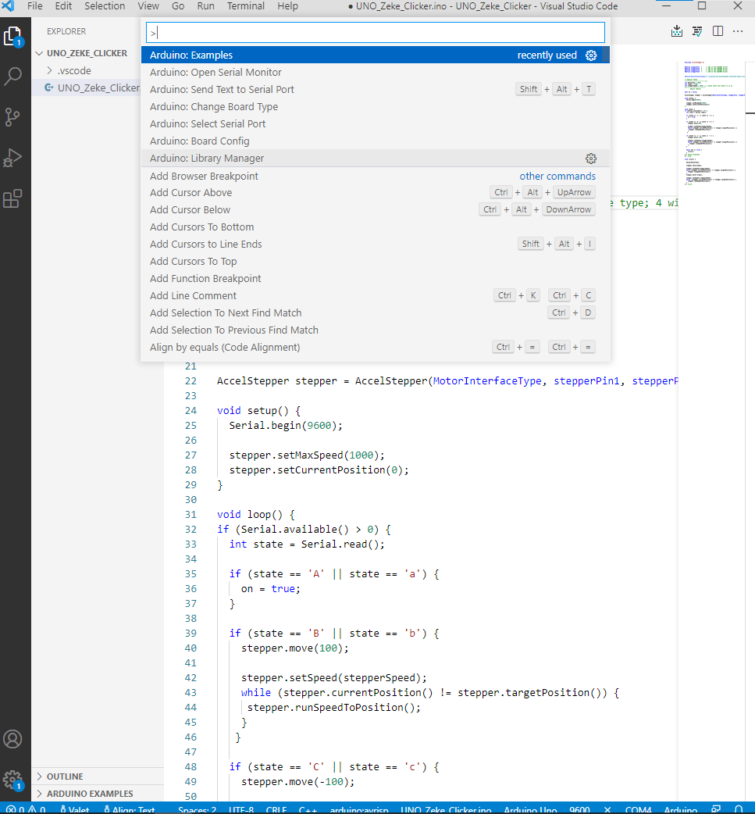
Search in the list for “Send text to serial port”
Hover over the option and click the gear next to the option
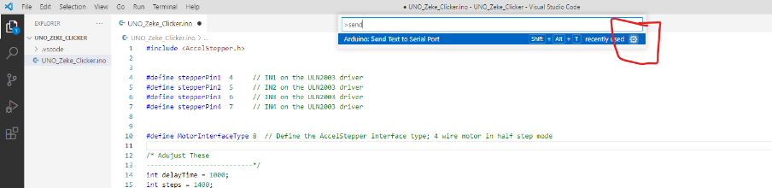
Click in the keybinding column and it will let you set up a shortcut. Do not just use ctrl and a letter or shift and a letter because it will interfere with other apps most likely. I used CTRL + ALT + T

